# Question 1:

mmWave communication is one of the emerging technologies for the future network like 5G. It uses frequency range from 30 GHz to 300 GHz. You are required to investigate the affects of frequency and distance both on the path loss. Write a matlab code considering the following conditions.

## Part 1:

Use free space path loss model to calculate pathloss in dB using frequency range 30 Ghz to 150 Ghz at distance of 60m and plot a graph to display the variation in pathloss.

### Path loss in watts;



### Path loss in dB:



### Code:

%% free space path loss DISTANCE-60m

frequency=30e9:0.1e9:150e9;

lambda=(3*10^8)./(frequency);

D=60; % distance in meters

Lp=((4*pi*D)./lambda).^2;

path_dB=10*log(Lp);

% plot(frequency./1e9,Lp);

plot(frequency./1e9,path_dB);

xlabel('Frequency (GHz)');

ylabel('Path loss (dB)');

title('Free space path loss for a distance of 60m');

## Part: 2

Use free space path loss model to calculate pathloss in dB using distance range 60m to 150m using frequency 40 Ghz plot a graph to display the variation in pathloss.

### Path loss in dB for distance variation:

Code:  
% free space path loss

frequency = 40e9; % frequency in Hz

lambda = 3e8 / frequency; % wavelength in meters

distance = 60:0.01:150; % distance in meters

Lp = (4 * pi * distance ./ lambda).^2; % path loss in watts

path_dB = 10 * log10(Lp); % path loss in dB

plot(distance, path_dB);

xlabel('Distance (m)');

ylabel('Path loss (dB)');

title(sprintf('Free space path loss for a frequency of %.2f GHz', frequency/1e9));

## Part:3

Use the following equation to calculate pathloss. Consider a non-line of sight (NLOS) communication with transmitter height 33m, receiver height 2.5m, fc=82Ghz.

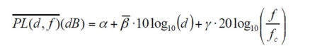

where α is the floating intercept, β is the average pathloss exponent, d is the distance from transmitter, f is the frequency used, fc is the carrier frequency, and γ is shadowing effect. Using the appropriate values of variables from the table given below to calculate path loss for frequency range f=30Gz to 120Ghz at d=30m and plot the comparison with part 1. Similarly, calculate pathloss for distance=50m to 100m and plot the comparison with part 2.

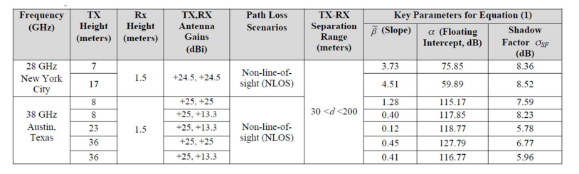

### Part : 1

**Code**

%% free space path loss DISTANCE-30m

frequency=30e9:0.1e9:150e9;

lambda=(3*10^8)./(frequency);

D=30; % distance in meters

Lp=((4*pi*D)./lambda).^2;

path_dB=10*log10(Lp);

% plot(frequency./1e9,Lp);

hold on

plot(frequency./1e9,path_dB);

%% Calculation of path loss:

frequency1=30e9:0.01e9:120e9; %frequency in GHz

D1=30; %distance in meters

Fc=82e9;

A=120.79;%floating point intercept

B=0.45; %slope

Y=6.77; %shadow factor

Lp1=A+B*(10*log10(D1))+Y*20*log10(frequency1./Fc);

plot(frequency1./1e9,Lp1);

xlabel('Frequency (GHz)');

ylabel('Path loss (dB)');

title('Free space path loss for a frequency of 90-150 GHz');

legend('Path loss 1', 'path loss 2');

### Graph:

### Part: 2

**Code:**

frequency = 40e9; % frequency in Hz

lambda = 3e8 / frequency; % wavelength in meters

distance = 50:0.01:150; % distance in meters

Lp = (4 * pi * distance ./ lambda).^2; % path loss in watts

path_dB = 10 * log10(Lp); % path loss in dB

hold on

plot(distance, path_dB);

xlabel('Distance (m)');

ylabel('Path loss (dB)');

title('Comparing Path Loss Models');

%% Calculation of path loss:

D1=50:0.01:100; %distance in meters

Fc=82e9;

A=120.79;%floating point intercept

B=0.45; %slope

Y=6.77; %shadow factor

Lp1=A+B*10.*log10(D1)+Y*20*log10(frequency/Fc);

plot(D1,Lp1);

% xlabel('Frequency (GHz)');

% ylabel('Path loss (dB)');

% title('Free space path loss for a distance of 10-150m');

legend('Path loss 1', 'path loss 2')

### Graph:

# Question:2

Consider the conditions mentioned in Question 1 calculate Received Power (Pr) in dB for part 1,2,3 using Pt=40dBm. Plot the graph in matlab and comment the variation in received power.

## Power Received part 1

### Code:

%% Recieved Power:

P_t=40;

frequency=30e9:0.1e9:150e9;

lambda=(3*10^8)./(frequency);

D=60; % distance in meters

Lp=((4*pi*D)./lambda).^2;

path_dB=10*log(Lp);

P_r=P_t-path_dB;

plot(frequency,P_r);

xlabel('Frequency');

ylabel('Recieved Power dB');

title(" Recieved Power as function of Frequency");

### Output:

## Power Received part 2

### Code

%% Recieved Power:

P_t=40;

frequency = 40e9; % frequency in Hz

lambda = 3e8 / frequency; % wavelength in meters

distance = 60:0.01:150; % distance in meters

Lp = (4 * pi * distance ./ lambda).^2; % path loss in watts

path_dB = 10 * log10(Lp); % path loss in dB

P_r=P_t-path_dB;

plot(distance,P_r);

xlabel('Distance');

ylabel('Recieved Power dB');

title(" Received Power plot");

### Output:

## Power Received part 3

### Code

Part (1)

% Define the parameters

freq1= linspace(30e9,150e9,1000); % frequency in Hz

distance1 = 60; % distance range in meters

freq2 = linspace(30e9,120e9,800); % frequency in Hz

distance2 = 30; % distance range in meters

PT = 40; %(in dBm)

PT_dBm = 10*log10(10^(PT/10)10^-3); % convert PT to dBm

hT = 33; %transmitter height

hR = 2.5; %receiver height

fc = 82e9; %carrier frequency

a = 127.79;

B = 0.45;

y = 6.77;

c = 3.010^8;

lambda1 = c./freq1; % wavelength in meters

lambda2 = c./freq2;

% Calculate the pathloss in dB using free space and NLOS loss model

pathloss_db1 = 10log10((4pidistance1./lambda1).^2);

pathloss_db2 = a + B10*log10(distance2) + y.20log10(freq2./fc);

received_power1 = PT_dBm - pathloss_db1;

received_power2 = PT_dBm - pathloss_db2;

% Plot the received power vs frequency

figure;

plot(freq1/1e9, received_power1);

hold on

plot(freq2/1e9, received_power2);

title('Received Power vs Frequency');

xlabel('Frequency (GHz)');

ylabel('Received Power (dBm)');

grid on;

legend('Distance = 60 m', 'Distance = 30 m');

ylim([-120, -20]);

xlim([30, 150]);

yticks(-120:10:-20);

xticks(30:10:150);

### Output:

Part (1)

### Code

Part(2)

% Define the parameters

freq = 40e9; % frequency in Hz

distance1 = linspace(60, 150); % distance range in meters

distance2 = linspace(50, 100); % distance range in meters

hT = 33; %transmitter height

hR = 2.5; %receiver height

fc = 82e9; %carrier frequency

a = 127.79;

B = 0.45;

y = 6.77;

c = 3.0*10^8;

lambda = c./freq; % wavelength in meters

% Calculate the pathloss in dB using free space and NLOS loss model

pathloss_db1 = 10log10((4pidistance1./lambda).^2);

pathloss_db2 = a + B10log10(distance2) + y.20log10(freq./fc);

received_power1 = 10log10((1./(4pidistance1./lambda)).^2); % free space path loss

received_power2 = PT_dB + 10log10(1) + 10log10(1) - pathloss_db2;

% Plot the pathloss vs distance

figure;

plot(distance1, received_power1);

hold on

plot(distance2, received_power2);

title('Received Power');

xlabel('Distance (m)');

ylabel('Received Power (dB)');

grid on;

legend('Free Space Path Loss', 'NLOS Path Loss');

### Output

Code(2)

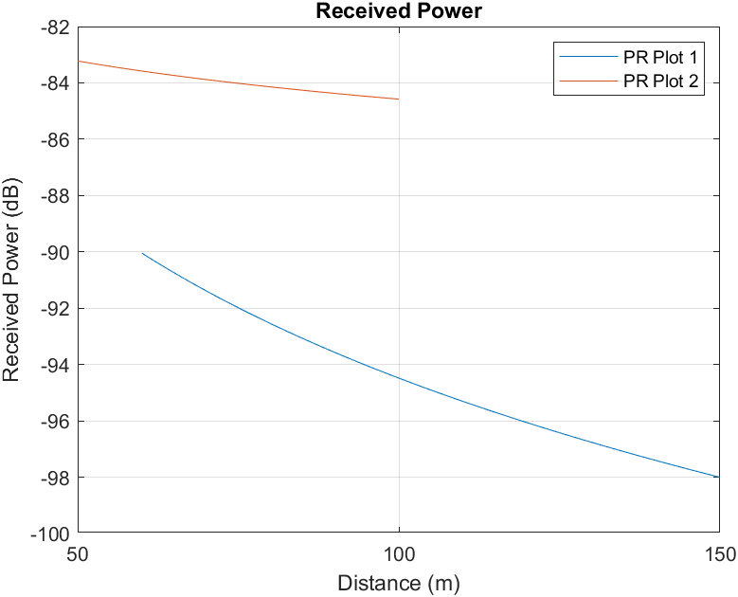

## Comments

Based on the findings, it is apparent that the power received is weaker in the non-line-of-sight (NLOS) model when compared to the free space model when we take into account the frequency of the signal. On the other hand, if we examine the difference in the distance between the transmitter and the receiver, the power received is generally lower for the free space model. Therefore, it can be concluded that the NLOS model experiences more significant power loss in terms of frequency variation, while the free space model suffers from more substantial power loss in terms of distance. These results have important implications for designing communication systems that operate in various environments, and further research is needed to explore the effects of different factors on signal propagation in different models.

# Question 3

The doppler shift is defined by the following equation where fm = v/λ and λ is the wavelength of arriving plane wave, θn is the angle of incidence of the plane wave arriving at the mobile station. Consider a transmitter is moving towards the The doppler shift is defined by the following equation where fm = v/λ and λ is the wavelength of arriving plane wave, θn is the angle of incidence of the plane wave arriving at the mobile station. Consider a transmitter is moving towards the

## Part 1:

Consider the conditions mentioned in Question 1 calculate Received Power (Pr) in dB for part 1,2,3 using Pt=40dBm. Plot the graph in matlab and comment the variation in received power.

%% Dopplers Shift:

v=60; % in Km/hr

f=800e6; %in Mhz

Theta=0:0.01:90;

Doppler_shift=(v/((3*10^8)/(f))).*cosd(Theta);

plot(Theta,Doppler_shift)

xlabel("Theta from 0 to 90 Degrees");

ylabel("Doppler Shift");

title("Effects of Theta on Doppler Shift")

grid on;

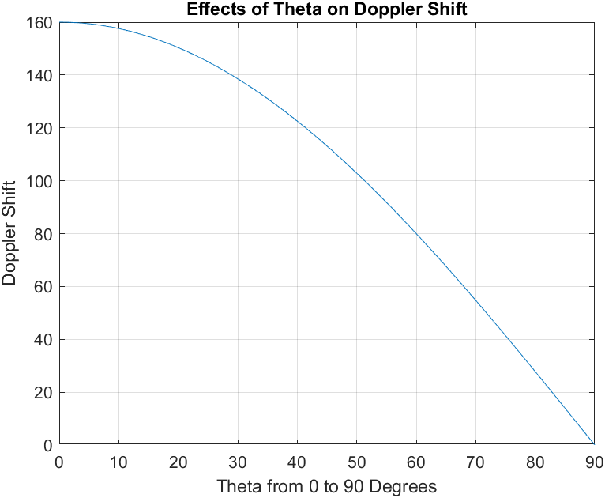

## Part 2:

Keeping all variable constant and vary f from 600Mhz to 900 Mhz to calculate doppler shift and plot the graph for frequency vs Doppler shift.

%% Dopplers Shift:

v=60; % in Km/hr

f=600e6:0.1e6:900e6; %in Mhz

Theta=55;

lambda=(3*10^8)./f;

Doppler_shift=(v./(lambda))*cosd(Theta);

plot(f./1e6,Doppler_shift)

xlabel("Frequency from 600 to 900 Mhz");

ylabel("Doppler Shift");

title("Effects of Frequency on Doppler Shift")

grid on;

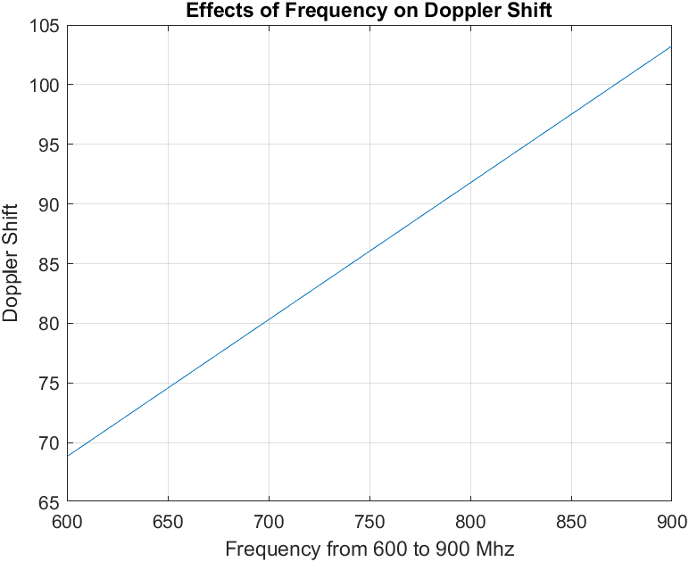

## Part: 3

Keeping all variable constant and vary v from 10kmph to 60kmph to calculate doppler shift and plot the graph for Velocity vs Doppler shift.

%% Dopplers Shift:

v=10:0.01:60; % in Km/hr

f=800e6; %in Mhz

Theta=55;

lambda=(3*10^8)/f;

Doppler_shift=(v./(lambda)).*cosd(Theta);

plot(v,Doppler_shift)

xlabel("Velocity from 10 to 60 Km/hr");

ylabel("Doppler Shift");

title("Effects of Velocity on Doppler Shift")

grid on;

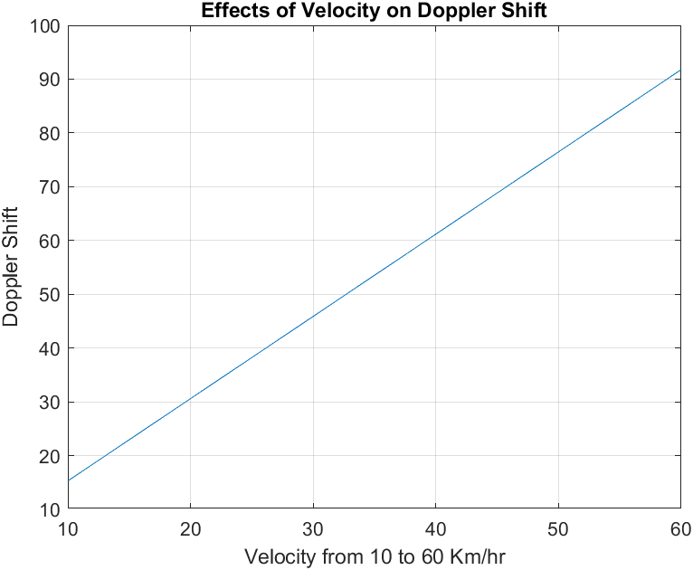

## Part:4:

Repeat the part 1,2 and 3 and consider the transmitter is moving away from the receiver.

### Effect of Theta:

%% Dopplers Shift:

v=-60; % in Km/hr

f=800e6; %in Mhz

Theta=0:0.01:90;

Doppler_shift=(v/((3*10^8)/(f))).*cosd(Theta);

plot(Theta,Doppler_shift)

xlabel("Theta from 0 to 90 Degrees");

ylabel("Doppler Shift");

title("Effects of Theta on Doppler Shift")

grid on;

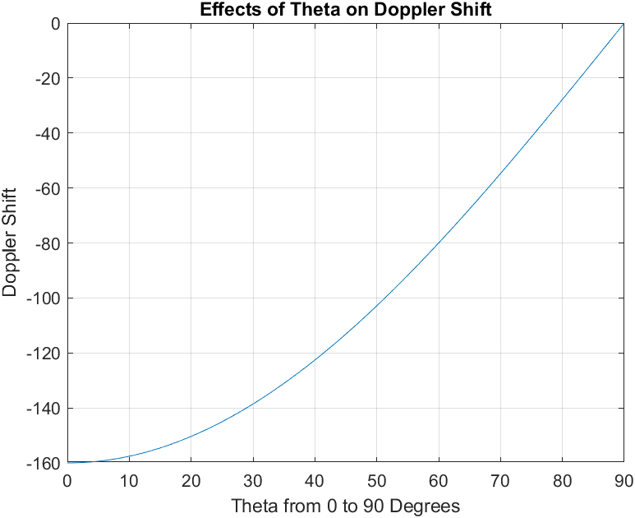

### Effect of frequency:

%% Dopplers Shift:

v=-60; % in Km/hr

f=600e6:0.1e6:900e6; %in Mhz

Theta=55;

lambda=(3*10^8)./f;

Doppler_shift=(v./(lambda))*cosd(Theta);

plot(f./1e6,Doppler_shift)

xlabel("Frequency from 600 to 900 Mhz");

ylabel("Doppler Shift");

title("Effects of Frequency on Doppler Shift")

grid on;

### Effect of velocity:

%% Dopplers Shift:

v=10:0.01:60; % in Km/hr

f=800e6; %in Mhz

Theta=55;

lambda=(3*10^8)/f;

Doppler_shift=(-v./(lambda)).*cosd(Theta);

plot(v,Doppler_shift)

xlabel("Velocity from 10 to 60 Km/hr");

ylabel("Doppler Shift");

title("Effects of Velocity on Doppler Shift")

grid on;

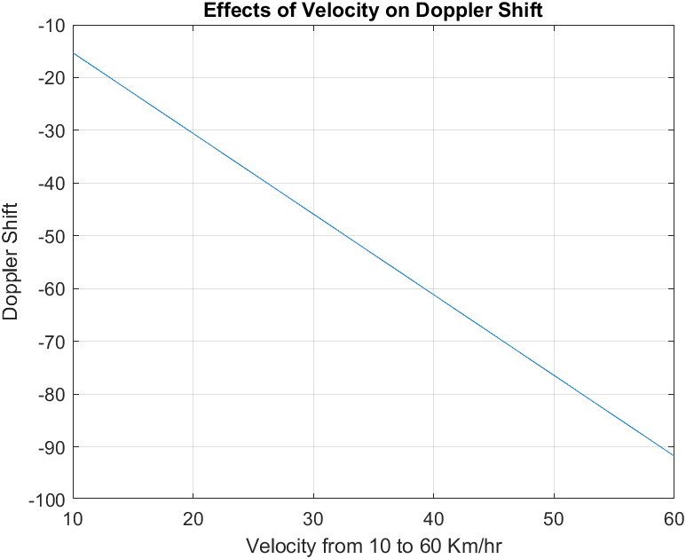

# Question:4

Consider the 2-ray model with transmitter height 35m, receiver height 10m, distance 60m, Gt=4, Gr=2, Pt=33dBm. Write a matlab code to calculate received power and pathloss using 2-ray model in dB.

%% 2-Ray model:

ht=35;

hr=10;

d=60;

Gt=4;

Gr=2;

path_loss=((d^2)/(ht*hr))^2;

Trans_power=(10^(33/10))*1e-3;

Recieved_power=((Trans_power)/(path_loss))*Gt*Gr;

Rec_DBM=10*log10(Recieved_power/(1e-3));

Rec_dB=10*log10(Recieved_power);

display('Power Recieved in dB is')

display(Rec_DBM);

display('Recived power in dB is');

display(Rec_dB)

## output

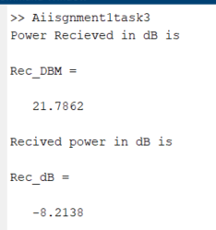

# Question 5:

Diffraction gain due to presence of knife edge is given by the equation mentioned below where parameter v is the Fresnelkirchoff diffraction parameter. Write a matlab code to calculate Diffraction gain for -3.5<=v<=3.5 and display the values of gain.

## Code:

%% Diffraction gain:

v=-3.5:0.01:3.5;

for n=1:length(v)

v_vector=v(n):0.01:v(n)+100;

F(n)=((1+1i)/2)*sum(exp((-1i*pi*(v_vector).^2)/2));

end

F=abs(F)/(abs(F(1)));

plot(v, 20*log10(F))

xlabel('Fresnel Diffraction Parameter')

ylabel('Diffraction gain (dB)')

title("Fresnel Kirchoff parameter vs Diffraction gain");

grid on;